A

Project Report

On

***College Hostel Management System***

Submitted in partial fulfillment of the requirements for the award of degree

#### Bachelor of Computer Application

#### From

Pt. Ravishankar Shukla University, Raipur (C.G.)

Year: 2016 -17

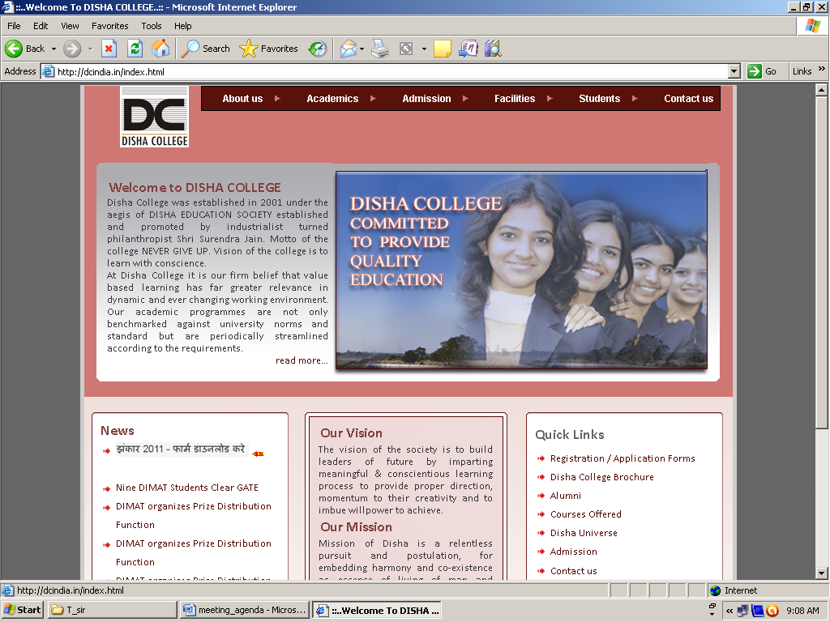

**Submitted by:**

Preet Sahu

Roll No:

**Guide**:

Mrs. Rekha Awasthi

Asst. Professor (Computer Sci.)

Submitted to

Disha College

**Pt. Ravishankar Shukla University, Raipur (C.G.)**

**CERTIFICATE OF APPROVAL**

This is to certify that the project work entitled **“COLLEGE HOSTEL MANAGEMENT”** is carried out by **Mr. Preet Sahu**, a student of BCA-III year at **Disha College** hereby approved as a credible work in the discipline of Computer Science & Information Technology for the award of degree of **Bachelor of Computer Application** during the year 2016-17 from **Pt. Ravishankar Shukla University, Raipur (CG).**

**Dr. A.K. Tiwari**

**Principal**

**Disha College, Raipur**

**CERTIFICATE**

This is to certify that the project work entitled **“COLLEGE HOSTEL MANAGEMENT”** submitted to **Disha College** is carried out by **Mr. PREET SAHU,** Roll No. _________________ in partial fulfilment for the requirements relating to the nature and standard of the award of **Bachelor of Computer Application** degree by **Pt. Ravishankar Shukla University, Raipur (CG)** for the academic year 2016 – 2017.

This project work has been carried out under my guidance.

**Guide**

**Mrs. Rekha Awasti**

**Asst. Prof. (Computer)**

**Disha College (CG)**

**CERTIFICATE OF EVALUATION**

This is to certify that the project work entitled **“COLLEGE HOSTEL MANAGEMENT”** is carried out by **Mr. Preet Sahu**, a student of BCA-III year at **Disha College** after my proper evaluation and examination, is hereby approved as a credible work in the discipline of Computer Science & Information Technology and is done in a satisfactory manner for the acceptance as a requisite for the award of the degree of **Bachelor of Computer Application** during the year 2016-17 from **Ravishankar Shukla University, Raipur (CG).**

**External Examiner**

**Internal Examiner**

**DECLARATION**

This is to certify that the project work entitled **“COLLEGE HOSTEL MANAGEMENT”** submitted by me in the partial fulfilment for the award of the degree of **Bachelor of Computer Application** to **Disha College,** comprises the original work carried out by me.

I further declare that the work reported in this project has not been submitted and will not be submitted, either in part or in full for the award of any other degree or diploma in this Institute or University.

**Place:Disha College, Raipur**

**Date:**

**Preet Sahu**

**Roll No :**